**Thomas Martin**

**CS-340-11221-M01 Client/Server Development 2024**

**5-1 Project One Submission**

**Southern New Hampshire University**

**June 07, 2024**

About the Project/Grazioso Salvare Animal Rescue Project

The CRUD Python module is designed to provide a straightforward and reusable interface for performing Create, Read, Update, and Delete operations on the MongoDB database used by Grazioso Salvare. This module abstracts the complexities of interacting directly with MongoDB, offering a clean and intuitive API for managing data.

The module simplifies database operations by providing a set of well-defined methods for basic operations, eliminating the need for writing repetitive and complex queries. It improves code reusability and maintainability by encapsulating CRUD operations within a class, ensuring consistent database interactions across the application. Integration with MongoDB’s user authentication enhances security by ensuring that only authorized users can perform operations on the database. Proper indexing strategies, implemented during the Module Three Milestone, optimize database queries for performance, making operations efficient even with large datasets. The module is designed using object-oriented programming principles, making the code more organized, modular, and easier to extend in the future.

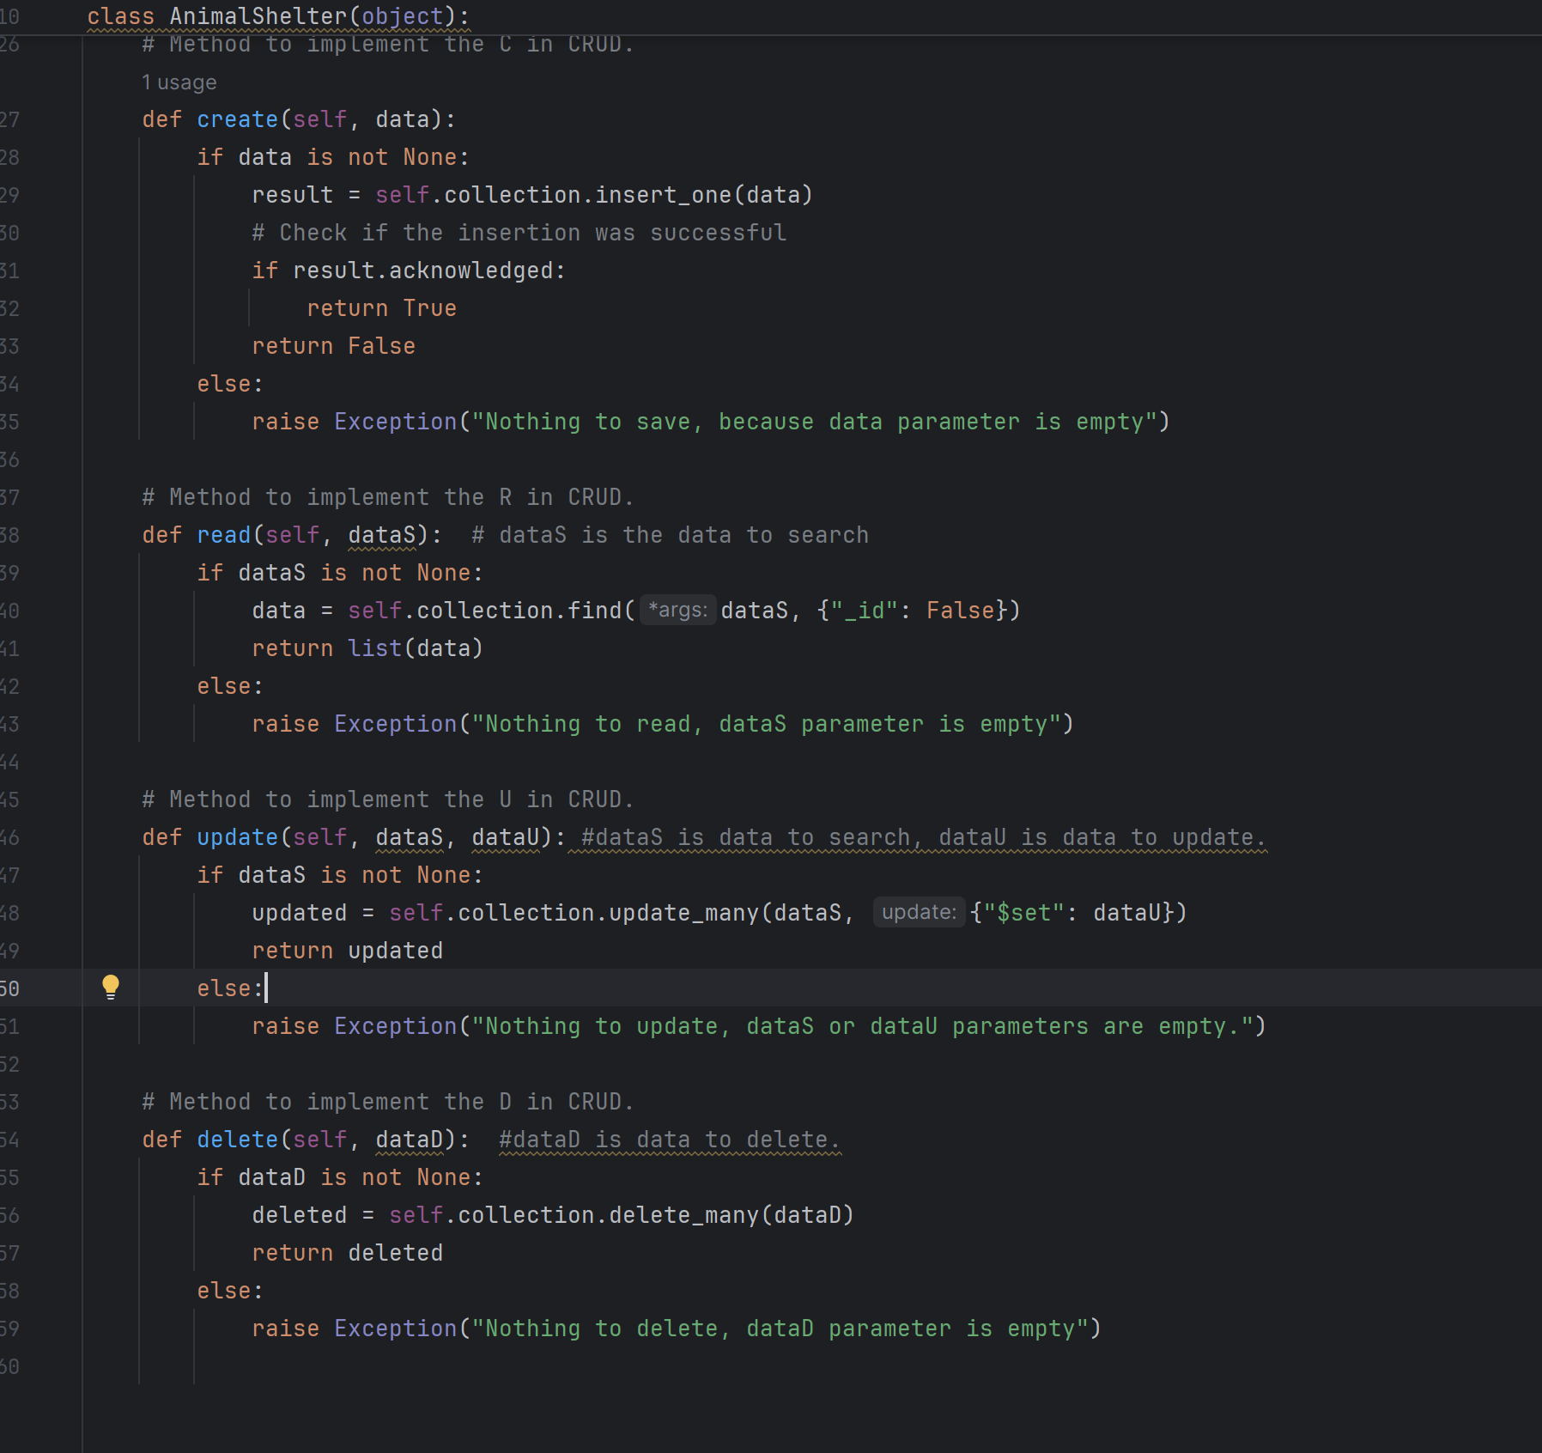

A demonstration of the module’s functional operations, including: Screenshots of the MongoDB import execution.

Screenshots of the user authentication execution.

Screenshots of the CRUD functionality test execution.

